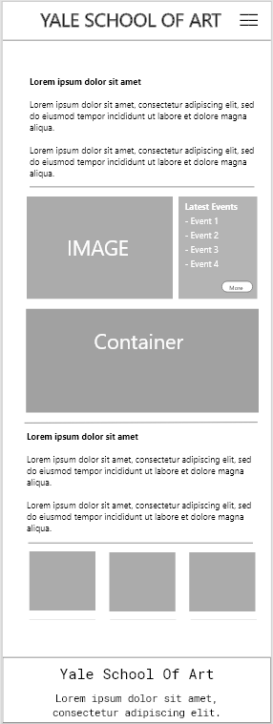

What is missing in this example?

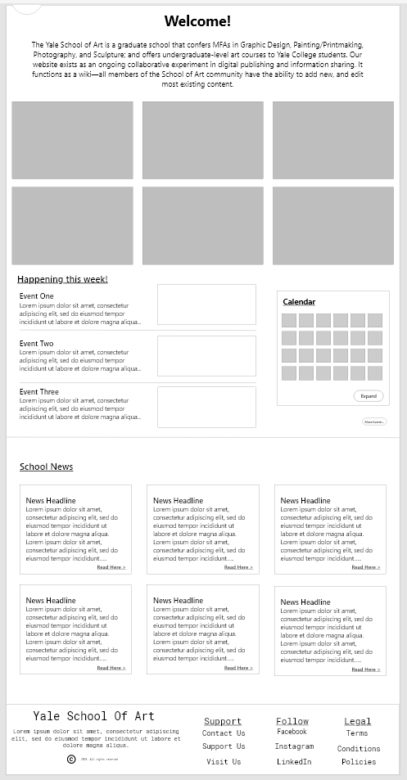

The navigation is missing. You should include your navigations in your wireframes